DON’T MISS THIS SPECIAL EVENT!
John R. Dailey “Zorro” Squadron Reunion
San Diego | April 17-19, 2024
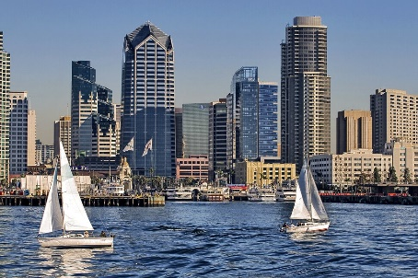
Make your reservation at the Embassy Suites Downtown today: https://bit.ly/3t1BYM8
We have a special low rate for your stay, which includes daily breakfast and happy hour.
No daily destination fee, free Wi-Fi, stay up to 3 days post reunion at our rate (subject to availability).

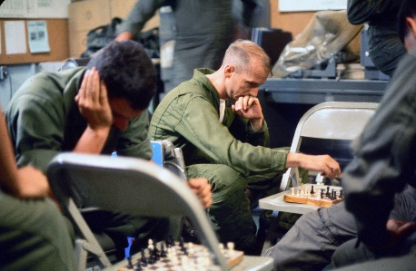
WHO’S INVITED? YOU!
Squadron members, any former VMAQ, VMCJ, VMFP, or VMO squadron members,
any USS Midway Marines, and any MCAA members who just love San Diego and MCAS Miramar, and their significant others!
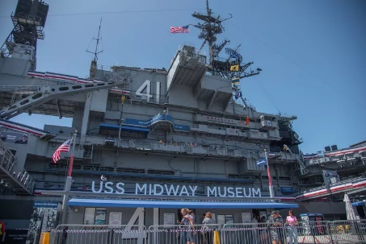
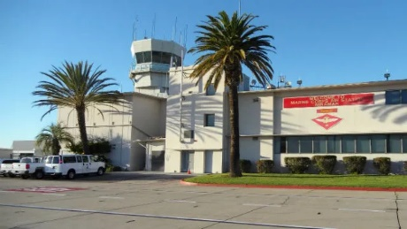
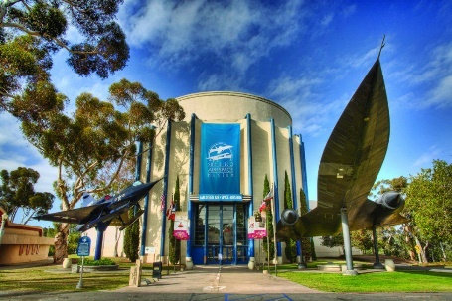

WHAT’S THE MISSION?
Our focus on this mission will be on the Marine EW and Photo Reconnaissance aviation.
- Welcome Gathering at the Hotel
- Memorial Service & Docent Led Tour of the USS Midway Museum
- Business Meeting
- Exclusive Dinner Event at the San Diego Museum of Air & Space
Private Docent Tour, Reception, Dinner with Special Guest Speaker
- Private Exclusive Tour of MCAS Miramar
Tour of Flightline by Active Pilots

ENLIST TODAY!
Zelle George Cook, 252-646-3365 your buy-in of $300 pp/ $600 per couple today!
We have a very limited space on board and will only take buy-ins at this rate within the next 30 days. *

If you have any questions, contact Len Ingram at 256-783-0013 or carolynlen@comcast.net.

